- You like …………..   - I would like some ……..   - He likes ....... 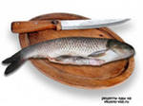  - They don’t like ……..   - We would like some ………  | - Would you like some ………… ?  - Do you like ………... ?  - Do they like …………. ?  - Would you like some …………. ?  - Does he like …………. ?
1
2
3
4
5

